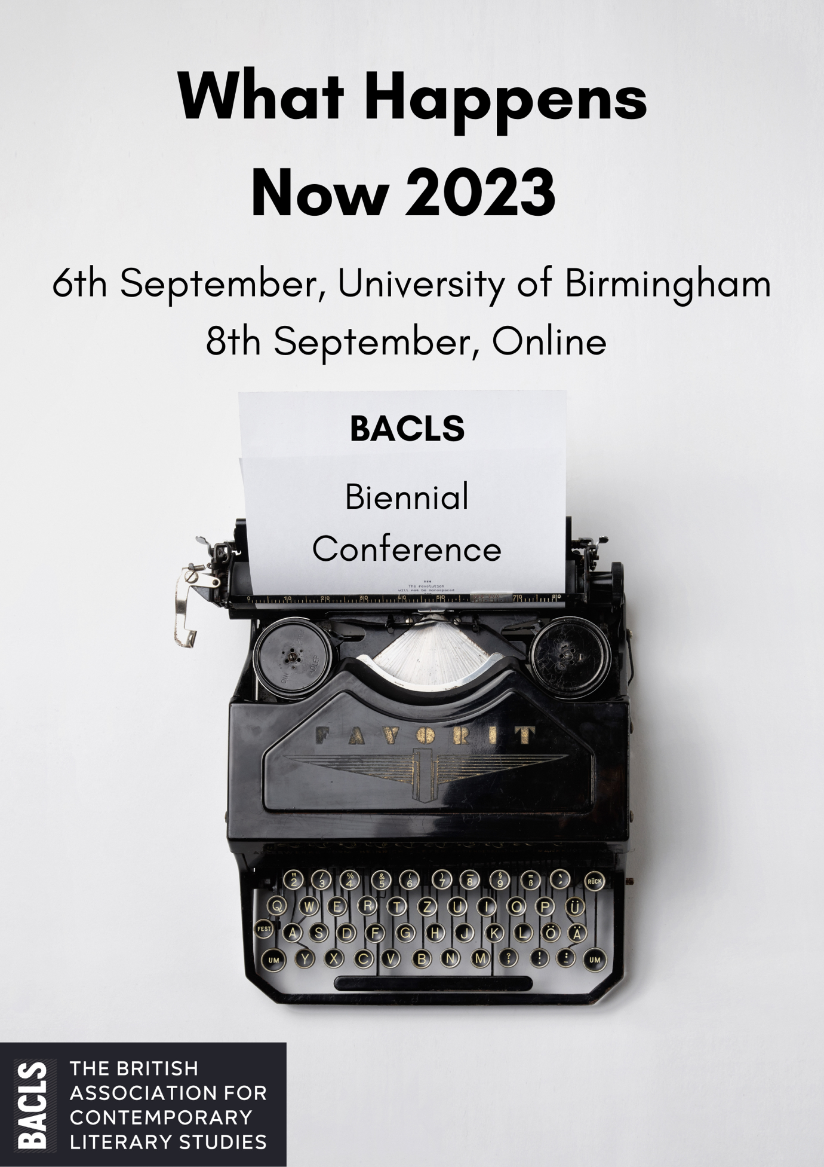
BACLS-WHN Conference: Old Gym, University of Birmingham, Wednesday 6 September 2023: Programme

9 a.m. Refreshments and welcome from BACLS (LG06)

9.15 Parallel panels A

A1 Contemporary Narratives of Work (LG06). Chair: Huw Marsh
Betsy Porritt (University of Birmingham): “‘I’d give up all my breaks for genuine leisure with you’: Registering a Poetics of Work”
Huw Marsh (Queen Mary University of London): “‘Bullshit’ Jobs and Ticklish Comedy: Humour and Sadness in the Contemporary Workplace Novel”

A2 Contemporary Irish Fiction: Narratives of Recovery (LG11). Chair: Dearbhaile Houston
Dearbhaile Houston (Trinity College, Dublin): “ʽalmost painfully happy’: Recovering the Marriage Plot in Sally Rooney’s Beautiful World, Where Are You”
Liam Harrison (University of West of England): “Stylish Magazines: Literary Journals and Contemporary Irish Literature”
Orlaith Darling (Trinity College, Dublin): “Literary Realism or, the Artistic Logic of Neoliberalism in Irish Women’s Fiction”

A3 National Identity and Landscape (LG10). Chair: Tom Fielder
Owain Burrell (University of Warwick): “The Forest and the Future of Englishness” Misbah Ahmed (Queen Mary University of London): “Anti-Capitalist Resistance in the British South Asian Pastoral Novel: Mona Arshi’s Somebody Loves You”
Jacob Miller (University College, Dublin): “The breath of past ideas”: Utopia, Unionism and Ambivalence in Andrew O’Hagan’s Our Fathers”
Tom Fielder (Birkbeck College, London): “A Dramatization of Brexit and Psychoanalysis”

10.45 Refreshments

11.00 Parallel panels B

B1 Diary Writing and Feminized Work (LG10). Chair: Charlotte Johanne Fabricius
Ida Aaskov Dolmer (University of Southern Denmark): “The Impossible Work-Life Balance: Diaristic Narration of Time Famine in Postfeminist Mum’s Lit”
Emily J. Hogg (University of Southern Denmark): “The Order of the Days: Using Diaristic Form in Contemporary Experimental Prose”
Charlotte Johanne Fabricius (University of Southern Denmark): “By the Hour: Concurrence and Care Work in Instagram Comics”

B2 Extensions of the Text: Intertextuality and Transmediality (LG11). Chair: David Wylot
David Wylot (University of Leeds): “Metabibliographic Fiction: The Theory and Practice of the Self-Conscious Book”
Caroline Wintersgill (University of Stirling): “The Anatomy of an Ending: Metatext, Intertext and Paratext in Kate Atkinson’s A God in Ruins”

B3 “Stories into Song” (LG06). Chair: Melanie Ebdon
Nick Bentley (Keele University)
Melanie Ebdon (Staffordshire University)
James Peacock (Keele University)

12.30 Buffet lunch

13.15 Keynote Roundtable. “Getting published in C21: Meet the Editorial team” (LG06). Chair: Siân Adiseshiah
Professor Siân Adiseshiah (Loughborough University)
Dr Zoe Bulaitis (University of Birmingham)
Dr Alice Bennett (Liverpool Hope University)
Dr Arin Keeble (Edinburgh Napier University)
Dr Oliver Haslam (University of Evansville)
Dr Melissa Schuh (Christian-Albrechts Universität zu Kiel)

14.00 Parallel panels C

C1 Words Lost, Broken and Recycled (LG11). Chair: Victor Rees
Victor Rees (University College London): “Broken Mouth: Alternative Disfluency in the Novels of B. Catling”
Adrienne Mortimer (University of Leeds): “The Lost Shape of Words: Reading the Post-literate Condition in Ali Smith’s Like (1997)”
Ed Garland (Aberystwyth University): “Literary Captions and Captionary Fiction”

C2 Queer, Feminist Narratives (LG06). Chair: Fiona Tolan
Fiona Tolan (Liverpool John Moores University): “A Life Can Be a Manifesto: Connecting Bernadine Evaristo to a History of Feminist Manifestos”
Amy Bouwer (University of Nottingham): “Backlash to the Future: Anti-Utopianism
in Contemporary Feminist SF”

C3 “Ishiguro and the Critics: The Author’s Role in Shaping Contemporary Critical Practice” (LG10). Chair: Nick Bentley (Keele University)
Dominic Dean (University of Sussex)
Peter Sloane (University of Buckingham)
Emily Horton (University of Brunel)
David James (University of Birmingham)

15.30 Refreshments

15.45 Parallel panels D

D1 The Human and the Post-human (LG06). Chair: James Baxter
Klara Machata (University of Freiburg): “’Each tiny human a cell of the beast’:
Human and Non-human Perspectives in Pitchaya Sudbanthad’s Bangkok Wakes to Rain”
David Tierney (University of Liverpool): “The Necessity of Uncertainty when Voicing Nonhuman Animals”
James Baxter (Trinity College Dublin): “Brian Evenson, Immobility, and ‘the world-
without-us’”

D2 Novel Feelings (LG10). Chair: Marta Zanucco
Alex J. Calder (University of Cambridge): “Rethinking Empathy: Essays and
Criticism by Namwali Serpell and Zadie Smith”
Marta Zanucco (University of Liverpool): “‘If I say, “This really happened,” then it’s true’: Performativity, Sincerity, and Collaboration in Barbara Browning’s The Gift”
Natalie Wall (University of Liverpool): “ʽI wanted everything turned up a little too high’: Realism, Neoliberalism and the (Im)possibilty of Recovery in Hanya Yanagihara’s A Little Life”
D3 Technology, Climate, Crisis (LG11). Chair: Dong Xia
Julia Ditter (University of Konstanz): “Explosive Pollen, Steam-Powered Vixen and Unseemly Science: Neo-Victorian Energy Regimes”
Dong Xia (University of St Andrews): “Damage Control: The Poetics of Insecurity in Ben Lerner’s 10:04”
Mathieu Bokestael (University College Dublin): “Insular Iconicity and Utopian Immunity: Inoculating the Self in Tamsin Calidas’ I am an island (2020)”
17.15 Closing remarks

BACLS-WHN Conference: Online, Friday 8 September 2023: Programme

9 a.m. Welcome remarks

9.15 “Contemporary Conversations” on the theme of literary prize culture, with Vidisha Biswas, Nick Hubble, Stevie Marsden and Nikesh Shukla

10.30 Refreshment break

10.45 Parallel panels A

A1 De-colonising, De-marginalising, Sampling, Coinings: Critical Pedagogies for Contemporary Literary Studies. Chair: John Roache
Jade Munslow Ong (University of Salford): De-colonising
John Roache (University of Manchester): De-marginalising
Veronica Barnsley (University of Sheffield): Sampling
Jade Cuttle (University of Cambridge): Coinings

A2 Diasporic, Political and Creative Solidarities in Contemporary British and Irish Narratives
Laura Aldeguer (University of Oviedo): “Political Solidarity at Work in Ali Smith’s Winter (2017)”
Carla Martínez del Barrio (University of Oviedo): “East European Migration to the UK and Diasporic Solidarity in Marina Lewycka’s Two Caravans (2007) and Kate Clanchy’s Antigona and Me (2008)”
Cristina Riaño Alonso (University of Oviedo): “Cosmopolitan Mediation and Creative Solidarity in Hannah Lavery’s Lament for Sheku Bayoh (2021)”
Matthew Lear (University of Edinburgh): “‘Constructing Collapse’: Fluid Systems and Infrastructural Crises in Mike McCormack’s Solar Bones”

A3 Familiar Strangeness: Identity Boundaries, History and Narrative Forms. Chair: Kai Tan
Carla Rodríguez González (Universidad de Oviedo): “Revisiting Historical Solidarity in Denise Mina’s Rizzio”
Camellia Choudhuri (Independent Researcher): “Haunting History: Examining Jay Bernard’s Hauntological Poetics in Surge (2019)”
Iris Pearson (University of Oxford): “Disrupted Decorum, Focalisation, and Readerly Hesitance in Angela Carter’s Experimental Novels”

12.15 Lunch break

13:00 BACLS AGM

14.00 Parallel panels B

B1 Pandemic Perspectives. Chair: Firuze Güzel
María Jesús Sánchez García (University of Oviedo): “Solidarity during Plague Times: Louise Welsh’s A Lovely Way to Burn”
Firuze Güzel (Ege University): “Imagining Life after Covid: Ethics of Tolerance in The Madness of Crowds”
B2 Contemporary Representations of People at the Margins, People in Jeopardy. Chair: James Peacock
Sophie Jones (University of Strathclyde): Genetic Futures of Pregnancy Sickness:
Sarah Hall’s ‘Mrs Fox’ at the Intersection of Disability and Animality”
Joseph Anderton (Birmingham City University): “Frames of Homelessness: Response Ethics and Writing Other Lives in Alexander Masters’s Stuart: A Life Backwards”
Sarah Dara (University of York): “Sexual Violence and ‘the Victim’ in South Asian Sex Trafficking Literature”
Gemma Marr (University of New Brunswick): “Love, Lust, and the Local: Representations of Queerness in Newfoundland Fiction”

B3 Mixed Media: Contemporary Literature’s Engagements with Other Forms. Chair: Devin Tupper
Maisie Ridgway (University of Sussex): “Meaning and Materiality in Allison Parrish’s Asemic AI Poetry”
Pankhuri Singh (University of Exeter): “The Adaptation of Shakespeare’s plays in Indian Cinema”
Devin Tupper (University College London): “Lives Between”

15.45 Refreshment break

16.00 Parallel panels C

C1 De-colonising, De-marginalising, Sampling, Coinings: Critical Pedagogies for Contemporary Literary Studies Part 2. Chair: Charlotte Beyer
Rebecca Bevington (University of York): “Taking Down Walls’: Border Crossings, Brutality and the Education of Human Rights in Enrique’s Journey by Sonia Nazario”
Charlotte Beyer (University of Gloucestershire): “Writing Back to History: Using Andrea Levy’s “Uriah’s War” as a Case Study for Decolonisation on a Level 4 Skills Module for English and Creative Writing Students”
Rebecca Roach (University of Birmingham): “Contemporary Literature from the Classroom”

C2 Visualities. Chair: Helen Penet
Helen Penet (Université de Lille): “Fiction in the Age of Digital Photography: A Case Study of some Contemporary Irish Women’s Writing”
Audrey Chan (University of Cambridge): “The Everyday Museum in Matisse’s Paintings: A. S. Byatt’s Matisse Stories.”

C3 Compromised Affects. Chair: Holly Parker
Holly Parker (University of Lincoln): “‘Leave it at Home’: Grieving and the Neoliberal Workplace in Margaret Atwood’s Hag-Seed”
Tommaso Villa (University of Lincoln): “‘Expressionless, Expresses God’: The Idealisation of the Athlete as a Tool for Neoliberal Personal Development in Chad Harbach’s The Art of Fielding”
Ágota Márton (University of Oxford): “Detachment and Millennial Closeness: Impersonal Perspective in Zadie Smith, Amit Chaudhuri, and Rachel Cusk”
Wiktoria Tunska (University of York): “‘Desperate and deranged dream’: Anger, Violence, and Carnival in J. G. Ballard’s Kingdom Come (2006)”

17.30-17.45 Closing remarks

